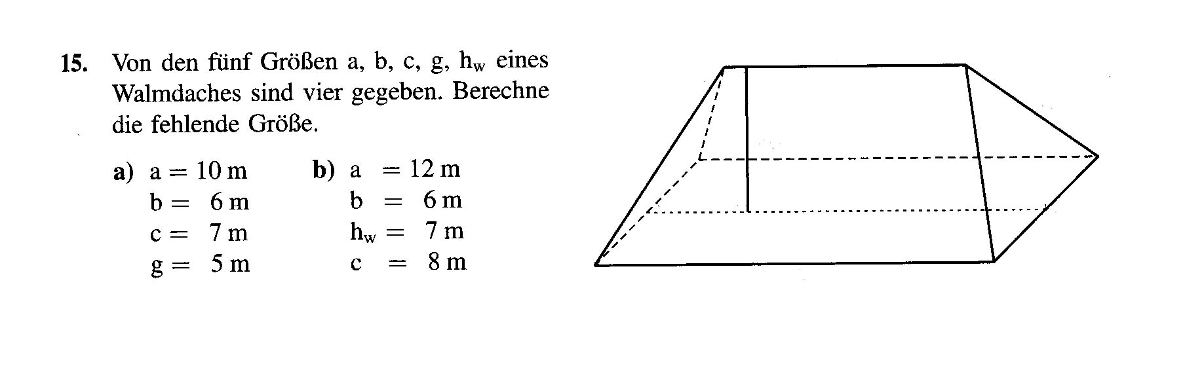
a
h_{w}
b
g
c

